Custom Xpath

//--this is how xpath starts

In the below example ‘a’ is the tag name

Class= ‘my-account......’ is one of the object properties

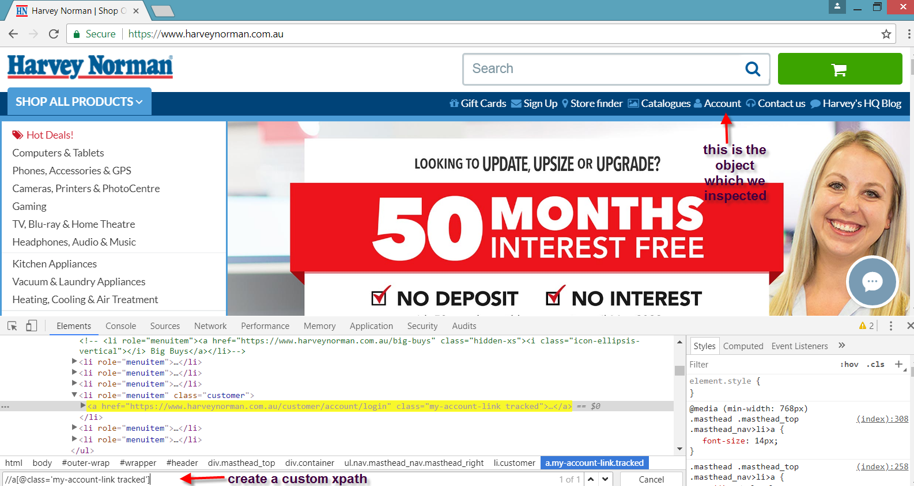

2. Contains

In this xpath we use contains option

Below is the custom xpath created for search function

//input[contains(@class,'form-control input-lg ui-autocomplete-input')]

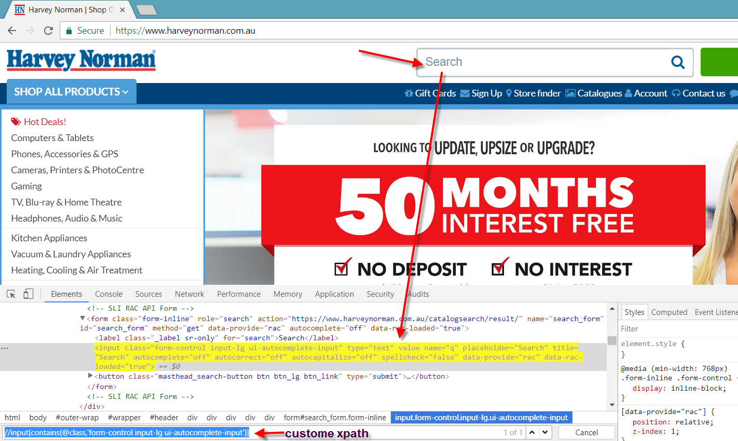

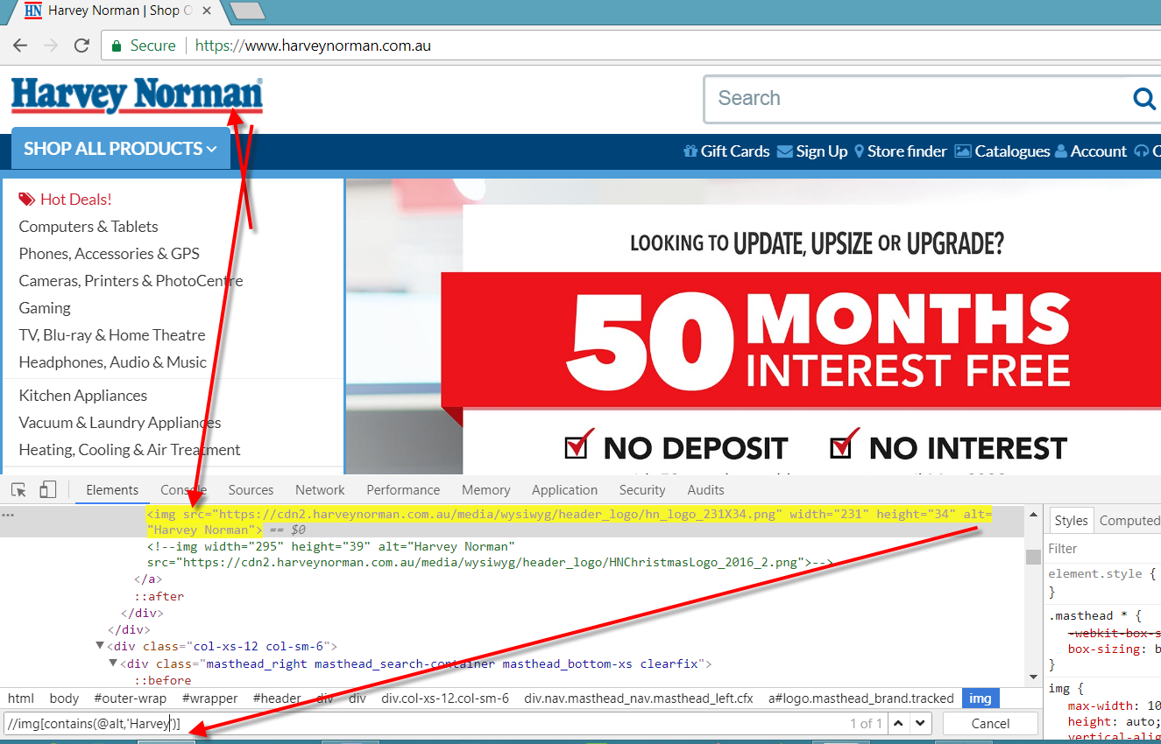

Version 2 of contains

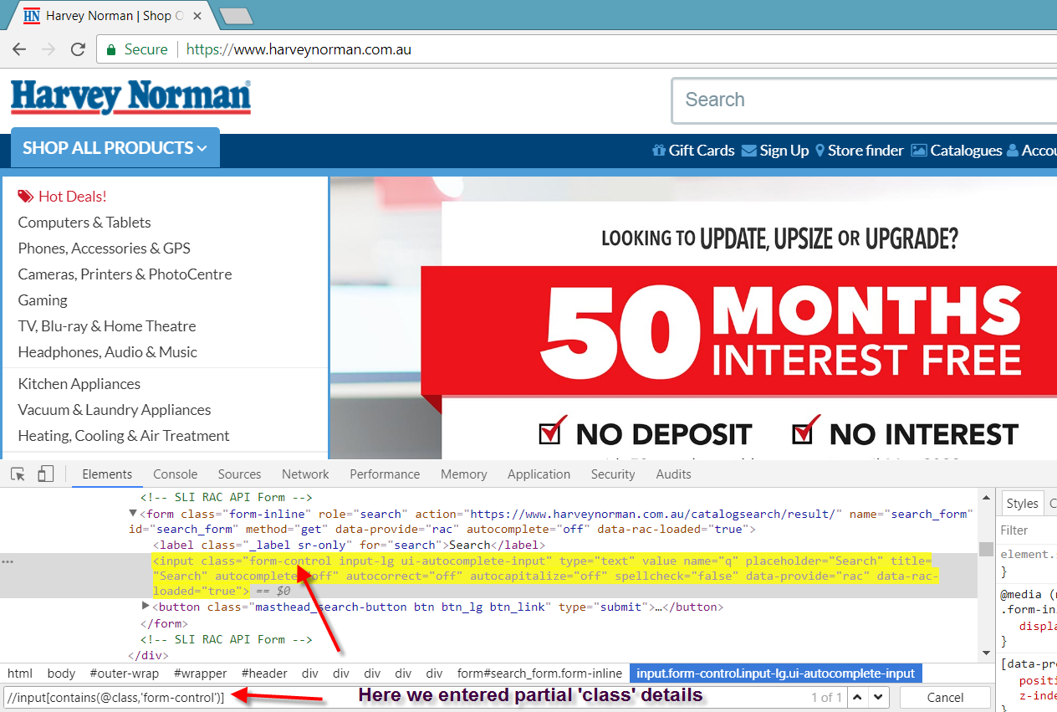

This above version is very important were object properties change dynamically

Example: we have an input box and lets imagine its id changes every time we reload the page

<input>id=itemno_123</input>

Second time when we load the page then id changes as below

<input>id=itemno_567</input>

In this sort of cases we have to use contains in xpath

**Driver.findElement(By.xpath(“//input[contains(@id,’itemno_’)]”)).sendKeys(“car”);**

**3. Starts-with**

**Driver.findElement(By.xpath(“//input[starts-with(@id,’itemno_’)]”)).sendKeys(“car”);**

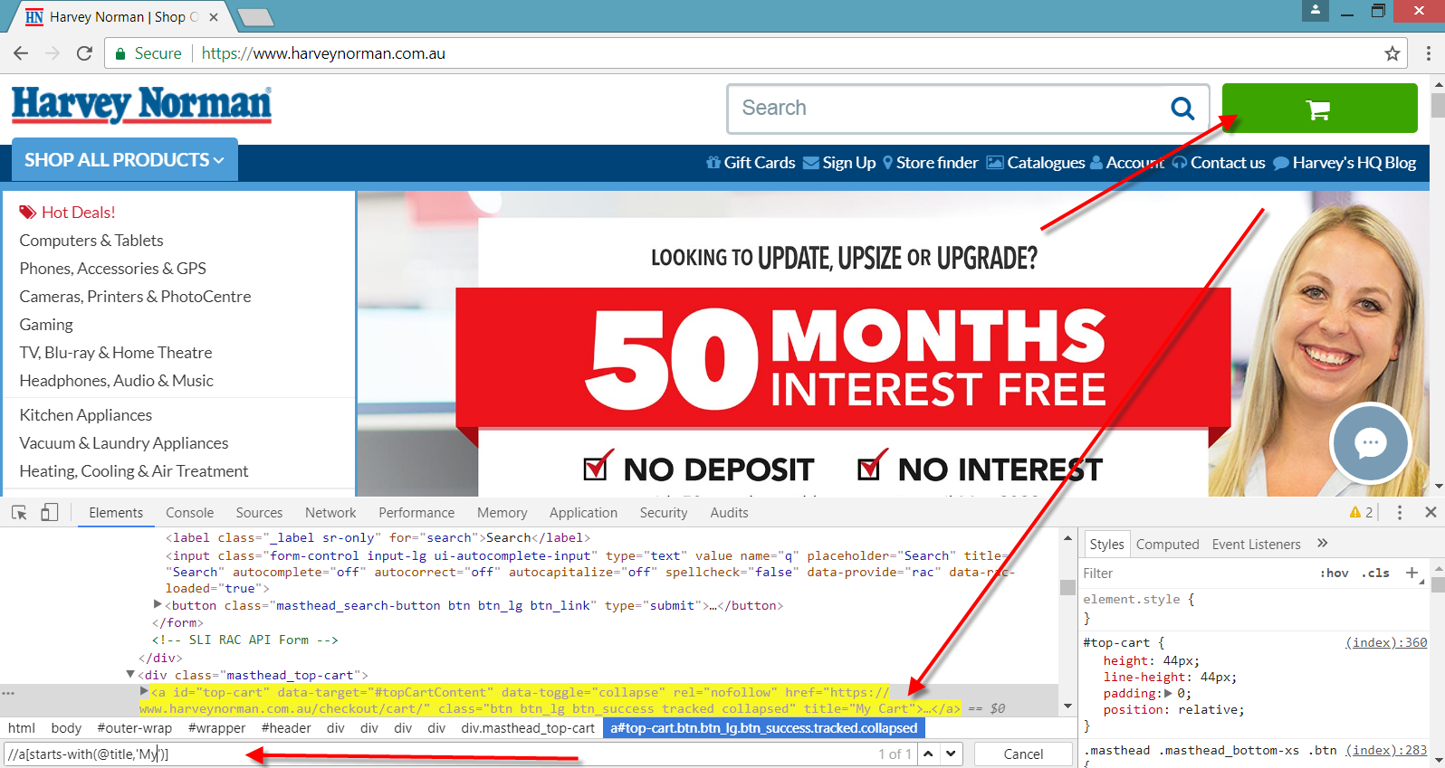

**4. ends-with**

**Id=1_item**

**Driver.findElement(By.xpath(“//input[ends-with(@id,’_item’)]”)).sendKeys(“car”);**

**Please check some examples online**

**5. contains(text())**

**Ex:**

**//span[contains(text(),'Store finder')]**

